**WEEK – 1:**

/*   Ques 1. Given an array of non-negative integers, design a linear

algorithm and implement it using a program to find whether given key

element is present in the array or not. Also, find total number of

comparisons for each input case.

(Time Complexity = O(n), where n is the size of input)

*/

import java.util.*;

public class Week1 {

    public static void main(String[] args){

        Scanner sc = new Scanner(System.in);

        // Input for number of test cases

        System.out.print("Enter the number of test cases: ");

        int T = sc.nextInt();

        // Loop for each test case

        for(int t = 1; t <= T; t++){

            // Input for size of array

            System.out.print("\nEnter the size of the array for test case

" + t + ":");

            int n = sc.nextInt();

            // Input for array elements

            int[] arr = new int[n];

            System.out.print("Enter the array elements for test case " +

t + ": ");

            for(int i = 0; i < n; i++){

                arr[i] = sc.nextInt();

            }

            // Input for key element to search for

            System.out.print("Enter the key element to search for in test

case " + t + ": ");

            int key = sc.nextInt();

            int comparisons = 0;

            boolean found = false;

            for(int i = 0; i < n; i++){

                comparisons++;

                if(arr[i] == key){

                    found = true;

                    break;

                }

            }

            if(found){

                System.out.println("Key element " + key + " is present is

array for test case " + t);

            }else{

                System.out.println("Key element " + key + " is not

present in array for test case " + t);

            }

            // Output total number of comparisons made

            System.out.println("Total number of comparisons made for test

case " + t + ": " + comparisons);

        }

    }

}

**\*\*\*\*\*\*\*\*OUTPUT\*\*\*\*\*\*\*\***

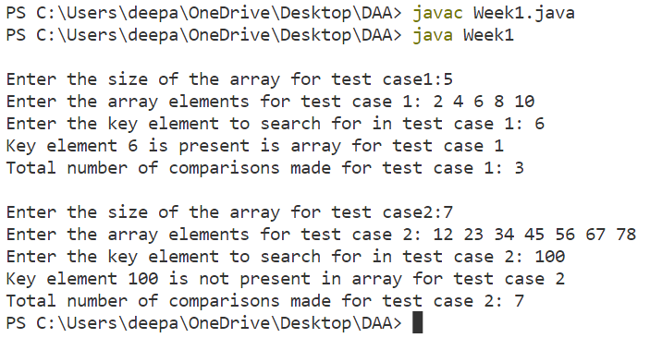

/*   Ques 2. Given an already sorted array of positive integers, design

An algorithm and implement it using a program to find whether given

key element is present in the array or not. Also, find total number

of comparisons for each input case. (Time Complexity = O(nlogn),

where n is the size of input).

*/

import java.util.*;

public class Week1 {

    public static void main(String[] args){

        Scanner sc = new Scanner(System.in);

        // Input for number of test cases

        System.out.print("Enter the number of test cases: ");

        int T = sc.nextInt();

        // Loop for each test case

        for(int t = 1; t <= T; t++){

            // Input for size of array

            System.out.print("\nEnter the size of the array for test case

" + t + ":");

            int n = sc.nextInt();

            // Input for array elements

            int[] arr = new int[n];

            System.out.print("Enter the array elements for test case " +

t + ": ");

            for(int i = 0; i < n; i++){

                arr[i] = sc.nextInt();

            }

            // Input for key element to search for

            System.out.print("Enter the key element to search for: ");

            int key = sc.nextInt();

            // Binary search to find whether key element is present in

array or not

            int comparisons = 0;

            int left = 0;

            int right = n - 1;

            boolean found = false;

            while(left <= right){

                int mid = (left + right) / 2;

                comparisons++;

                if(arr[mid] == key){

                    found = true;

                    break;

                }else if(arr[mid] < key){

                    left = mid + 1;

                }else{

                    right = mid - 1;

                }

            }

            if(found){

                System.out.print("Present ");

            }else{

                System.out.print("Not Presentm ");

            }

            System.out.print(comparisons);

        }

    }

}

**\*\*\*\*\*\*\*\*OUTPUT\*\*\*\*\*\*\*\***

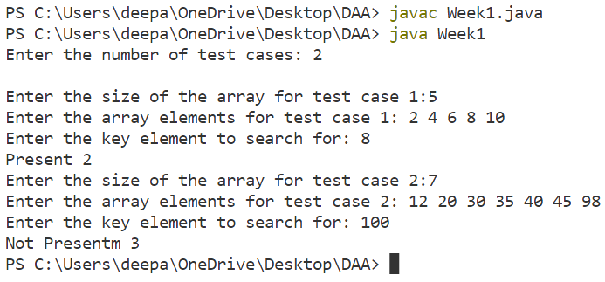

/*   Ques 3.  Given an already sorted array of positive integers, design an algorithm and implement it using a program to find whether a given key element is present in the sorted array or not. For an array arr[n], search at the indexes arr[0], arr[2], arr[4],.....,

arr[2k] and so on. Once the interval (arr[2k] < key < arr[ 2k+1] ) is found, perform a linear search operation from the index 2k to find the element key. (Complexity < O(n), where n is the number of elements need to be scanned for searching): Jump Search

*/

import java.util.*;

public class Week1 {

    public static void main(String[] args) {

        Scanner sc = new Scanner(System.in);

        // Input for number of test cases

        System.out.print("Enter the number of test cases: ");

        int T = sc.nextInt();

        // Loop for each test case

        for(int t = 1; t <= T; t++){

            // Input for size of array

            System.out.print("\nEnter the size of the array for test case

" + t + ": ");

            int n = sc.nextInt();

            // Input for array elements

            int[] arr = new int[n];

            System.out.print("Enter the array elements for test case " +

t + ": ");

            for(int i = 0; i < n; i++){

                arr[i] = sc.nextInt();

            }

            // Input for key element to search for

            System.out.print("Enter the key element to search for: ");

            int key = sc.nextInt();

// Jump search to find whether key element is present in array or not

            int comparisons = 0;

            int step = (int) Math.floor(Math.sqrt(n));

            int prev = 0;

            while(arr[Math.min(step, n) - 1] < key){

                comparisons++;

                prev = step;

                step += (int)Math.floor(Math.sqrt(n));

                if(prev >= n){

                    break;

                }

            }

            while(arr[prev] < key){

                comparisons++;

                prev++;

                if(prev == Math.min(step, n)){

                    break;

                }

            }

            if(arr[prev] == key){

                System.out.print("Present");

            }else{

                System.out.print("Not Present");

            }

            System.out.println(comparisons);

        }

    }

}

**\*\*\*\*\*\*\*\*OUTPUT\*\*\*\*\*\*\*\***

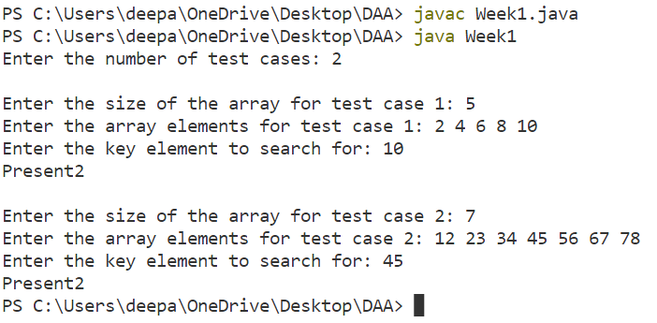

**WEEK – 2:**

/*   Ques 1. Given a sorted array of positive integers containing few duplicate elements, design an algorithm and implement it using a program to find whether the given key element is present in the array or not. If present, then also find the number of copies of given key. (Time Complexity = O(log n))

*/

import java.util.*;

public class Week2{

    public static void main(String[] args){

        Scanner sc = new Scanner(System.in);

        // Input for number of test cases

        System.out.print("Enter the number of test cases: ");

        int T = sc.nextInt();

        // Loop for each test case

        for(int t = 1; t <= T; t++){

            // Input for size of array

            System.out.print("\nEnter the size of the array for test case

" + t + ": ");

            int n = sc.nextInt();

            // Input for array elements

            int[] arr = new int[n];

            System.out.print("Enter the array elements for test case " +

t + ": ");

            for(int i = 0; i < n; i++){

                arr[i] = sc.nextInt();

            }

            // Input for key element to search for

            System.out.print("Enter the key element to search for: ");

            int key = sc.nextInt();

            int first = 0;

            int last = n - 1;

            int mid;

            int count = 0;

            while(first <= last){

                mid = (first + last) / 2;

                if(arr[mid] == key){

                    count++;

                    int left = mid - 1;

                    while(left >= 0 && arr[left] == key){

                        count++;

                        left--;

                    }

                    int right = mid + 1;

                    while(right < n && arr[right] == key){

                        count++;

                        right++;

                    }

                    break;

                }else if(arr[mid] < key){

                    first = mid + 1;

                }else{

                    last = mid - 1;

                }

            }

            if(count == 0){

                System.out.print("Key not Present");

            }else{

                System.out.print(key);

                System.out.print(" " + count);

            }

        }

    }

}

**\*\*\*\*\*\*\*\*OUTPUT\*\*\*\*\*\*\*\***

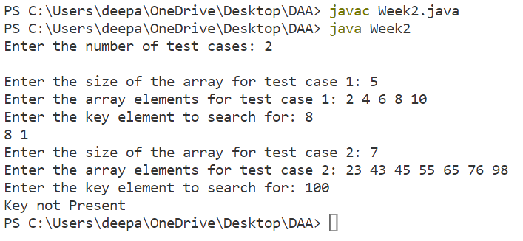

/*   Ques 2. Given a sorted array of positive integers, design an algorithm and implement it using a program to find three indices i, j, k such that arr[i] + arr[j] = arr[k].

*/

import java.util.*;

public class Week2{

    public static void main(String[] args) {

        Scanner sc = new Scanner(System.in);

        // Input for number of test cases

        System.out.print("Enter the number of test cases: ");

        int T = sc.nextInt();

        // Loop for each test case

        for(int t = 1; t <= T; t++){

            // Input for size of array

            System.out.print("\nEnter the size of the array for test case

" + t + ": ");

            int n = sc.nextInt();

            // Input for array elements

            int[] arr = new int[n];

            System.out.print("Enter the array elements for test case " +

t + ": ");

            for(int i = 0; i < n; i++){

                arr[i] = sc.nextInt();

            }

// Find three indices i, j, k such that arr[i] + arr[j] = arr[k]

            boolean found = false;

            for(int i = 0; i < n - 2; i++){

                int j = i + 1;

                int k = n - 1;

                while(j < k){

                    if(arr[i] + arr[j] == arr[k]){

                        found = true;

                        System.out.println(i + ", " + j + ", " + k);

                        break;

                    }else if (arr[i] + arr[j] < arr[k]){

                        j++;

                    }else{

                        k--;

                    }

                }

                if(found){

                    break;

                }

            }

            if(!found){

                System.out.println("No Sequence Found");

            }

        }

    }

}

**\*\*\*\*\*\*\*\*OUTPUT\*\*\*\*\*\*\*\***

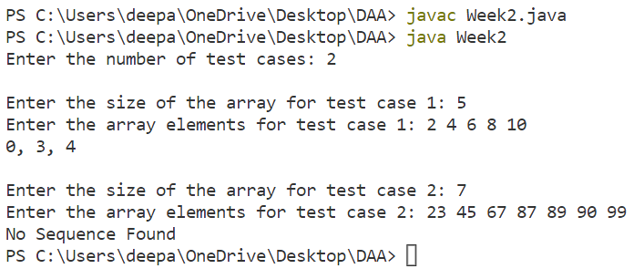

/*   Ques 3. Given an array of nonnegative integers, design an algorithm and a program to count the number of pairs of integers such that their difference is equal to a given key, K.

*/

import java.util.*;

public class Week2{

    public static void main(String[] args) {

        Scanner sc = new Scanner(System.in);

        // Input for number of test cases

        System.out.print("Enter the number of test cases: ");

        int T = sc.nextInt();

        // Loop for each test case

        for(int t = 1; t <= T; t++){

            // Input for size of array

            System.out.print("\nEnter the size of the array for test case

" + t + ": ");

            int n = sc.nextInt();

            // Input for array elements

            int[] arr = new int[n];

            System.out.print("Enter the array elements for test case " +

t + ": ");

            for(int i = 0; i < n; i++){

                arr[i] = sc.nextInt();

            }

            // Input for key K

            System.out.print("Enter the key: ");

            int K = sc.nextInt();

            // Count pairs whose difference is K

            int count = 0;

            for(int i = 0; i < n - 1; i++){

                for(int j = i + 1; j < n; j++){

                    if(Math.abs(arr[i] - arr[j]) == K){

                        count++;

                    }

                }

            }

            System.out.println(count);

        }

    }

}

**\*\*\*\*\*\*\*\*OUTPUT\*\*\*\*\*\*\*\***

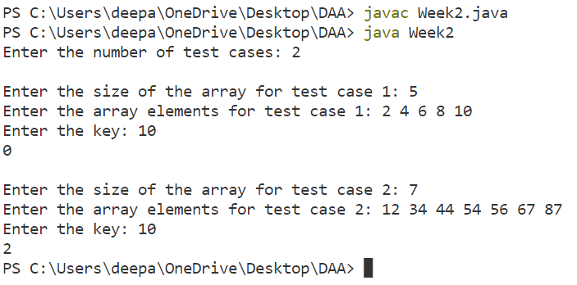

**WEEK – 3:**

/*   Ques 1. Given an unsorted array of integers, design an algorithm and a program to sort the array using insertion sort. Your program should be able to find number of comparisons and shifts ( shifts -

total number of times the array elements are shifted from their place) required for sorting the array.

*/

import java.util.*;

public class Week3{

    public static void main(String[] args) {

        Scanner sc = new Scanner(System.in);

        // Input for number of test cases

        System.out.print("Enter the number of test cases: ");

        int T = sc.nextInt();

        // Loop for each test case

        for(int t = 1; t <= T; t++){

            // Input for size of array

            System.out.print("\nEnter the size of the array for test case

" + t + ": ");

            int n = sc.nextInt();

            // Input for array elements

            int[] arr = new int[n];

            System.out.print("Enter the array elements for test case " +

t + ": ");

            for(int i = 0; i < n; i++){

                arr[i] = sc.nextInt();

            }

// Sort the array using insertion sort and count comparisons and shifts

            int comparisons = 0;

            int shifts = 0;

            for(int i = 1; i < n; i++){

                int key = arr[i];

                int j = i - 1;

                while(j >= 0 && arr[j] > key){

                    arr[j + 1] = arr[j];

                    j--;

                    comparisons++;

                    shifts++;

                }

                arr[j + 1] = key;

                shifts++;

            }

            System.out.print("Sorted array: ");

            for(int i = 0; i < n; i++){

                System.out.print(arr[i] + " ");

            }

            System.out.println();

            System.out.println("Number of comparisons: " + comparisons);

            System.out.println("Number of shifts: " + shifts);

        }

    }

}

**\*\*\*\*\*\*\*\*OUTPUT\*\*\*\*\*\*\*\***

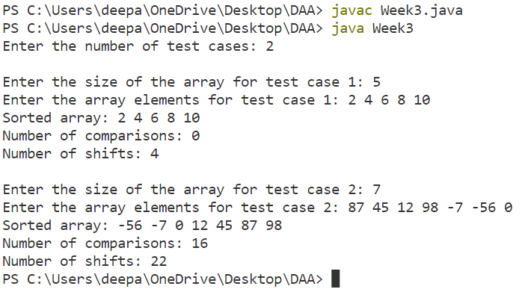

/*   Ques 2. Given an unsorted array of integers, design an algorithm and implement a program to sort this array using selection sort. Your program should also find number of comparisons and number of

    swaps required.

*/

import java.util.*;

public class Week3{

    public static void main(String[] args) {

        Scanner sc = new Scanner(System.in);

        // Input for number of test cases

        System.out.print("Enter the number of test cases: ");

        int T = sc.nextInt();

        // Loop for each test case

        for(int t = 1; t <= T; t++){

            // Input for size of array

            System.out.print("\nEnter the size of the array for test case

" + t + ": ");

            int n = sc.nextInt();

            // Input for array elements

            int[] arr = new int[n];

            System.out.print("Enter the array elements for test case " +

t + ": ");

            for(int i = 0; i < n; i++){

                arr[i] = sc.nextInt();

            }

// Sort the array using selection sort and count comparisons and swaps

            int comparisons = 0;

            int swaps = 0;

            for(int i = 0; i < n - 1; i++){

                int minIndex = i;

                for(int j = i + 1; j < n; j++){

                    if(arr[j] < arr[minIndex]){

                        minIndex = j;

                    }

                    comparisons++;

                }

                if(minIndex != i){

                    int temp = arr[i];

                    arr[i] = arr[minIndex];

                    arr[minIndex] = temp;

                    swaps++;

                }

            }

            System.out.print("Sorted array: ");

            for(int i = 0; i < n; i++){

                System.out.print(arr[i] + " ");

            }

            System.out.println();

            System.out.println("Number of comparisons: " + comparisons);

            System.out.println("Number of swaps: " + swaps);

        }

    }

}

**\*\*\*\*\*\*\*\*OUTPUT\*\*\*\*\*\*\*\***

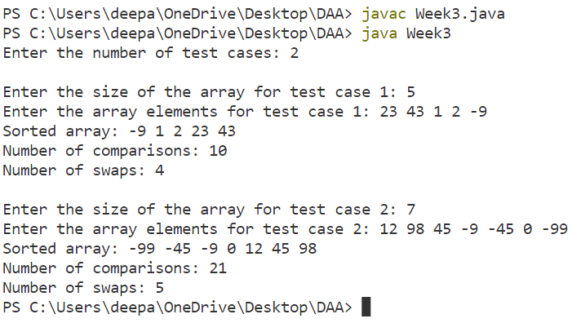

/*   Ques 3. Given an unsorted array of positive integers, design

an algorithm and implement it using a program to find whether there are any duplicate elements in the array or not. (use sorting) (Time

    Complexity = O(n log n))

*/

import java.util.*;

public class Week3{

    public static void main(String[] args) {

        Scanner sc = new Scanner(System.in);

        // Input for number of test cases

        System.out.print("Enter the number of test cases: ");

        int T = sc.nextInt();

        // Loop for each test case

        for(int t = 1; t <= T; t++){

            // Input for size of array

            System.out.print("\nEnter the size of the array for test case

" + t + ": ");

            int n = sc.nextInt();

            // Input for array elements

            int[] arr = new int[n];

            System.out.print("Enter the array elements for test case " +

t + ": ");

            for(int i = 0; i < n; i++){

                arr[i] = sc.nextInt();

            }

            Arrays.sort(arr);

            int flag = 0;

            for(int i = 0; i < n-1 ; i++){

                if(arr[i] == arr[i + 1]){

                    flag = 1;

                    break;

                }

            }

            if(flag == 1){

                System.out.println("Duplicate elements found");

            }else{

                System.out.println("No duplicate elements found");

            }

        }

    }

**\*\*\*\*\*\*\*\*OUTPUT\*\*\*\*\*\*\*\***

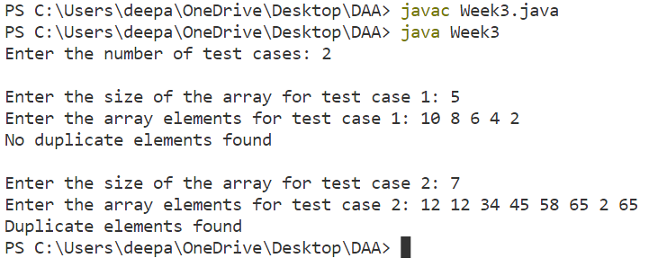

**WEEK – 4:**

/*   Ques 1. Given an unsorted array of integers, design an algorithm and implement it using a program to sort an array of elements by dividing the array into two subarrays and combining these subarrays

after sorting each one of them. Your program should also find number of comparisons and inversions during sorting the array.

*/

import java.util.*;

public class Week4{

    static int countComparisons, countInversions;

    public static void merge(int[] arr, int left, int mid, int right){

        int n1 = mid - left + 1;

        int n2 = right - mid;

        int[] L = new int[n1];

        int[] R = new int[n2];

        for(int i = 0; i < n1; i++)

            L[i] = arr[left + i];

        for(int j = 0; j < n2; j++)

            R[j] = arr[mid + 1 + j];

        int i = 0, j = 0;

        int k = left;

        while(i < n1 && j < n2){

            countComparisons++;

            if(L[i] <= R[j]){

                arr[k] = L[i];

                i++;

            }else{

                arr[k] = R[j];

                j++;

                countInversions += (n1 - i);

            }

            k++;

        }

        while(i < n1){

            arr[k] = L[i];

            i++;

            k++;

        }

        while(j < n2){

            arr[k] = R[j];

            j++;

            k++;

        }

    }

    public static void mergeSort(int[] arr, int left, int right){

        if(left < right){

            int mid = (left + right) / 2;

            mergeSort(arr, left, mid);

            mergeSort(arr, mid + 1, right);

            merge(arr, left, mid, right);

        }

    }

    public static void main(String[] args){

        Scanner sc = new Scanner(System.in);

        // Input for number of test cases

        System.out.print("Enter the number of test cases: ");

        int T = sc.nextInt();

        // Loop for each test case

        for(int t = 1; t <= T; t++){

            // Input for size of array

            System.out.print("\nEnter the size of the array for test case

" + t + ": ");

            int n = sc.nextInt();

            // Input for array elements

            int[] arr = new int[n];

            System.out.print("Enter the array elements for test case " +

t + ": ");

            for(int i = 0; i < n; i++){

                arr[i] = sc.nextInt();

            }

            int l = arr.length;

            mergeSort(arr, 0, n - 1);

            System.out.println("Sorted array:");

            for(int i = 0; i < l; i++)

                System.out.print(arr[i] + " ");

            System.out.println("\nNumber of comparisons: " +

countComparisons);

            System.out.println("Number of inversions: " +

countInversions);

        }

    }

}

**\*\*\*\*\*\*\*\*OUTPUT\*\*\*\*\*\*\*\***

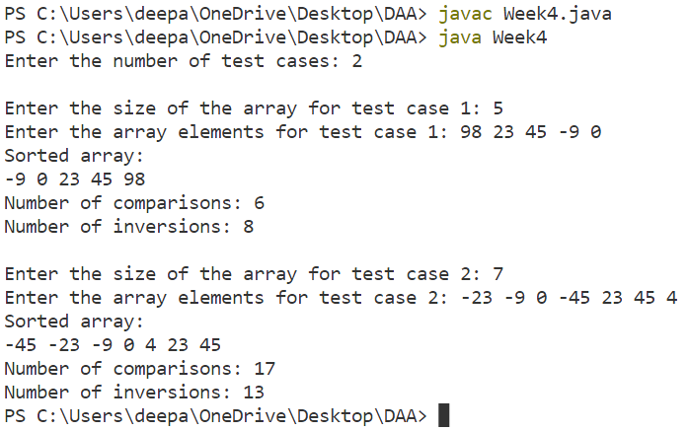

/*   Ques 2. Given an unsorted array of integers, design an algorithm and

implement it using a program to sort an array of elements by partitioning the array into two subarrays based on a pivot element

such that one of the sub array holds values smaller than the pivot element while another sub array holds values greater than the pivot element. Pivot element should be selected randomly from the array. Your program should also find number of comparisons and swaps required for sorting the array.

*/

import java.util.*;

public class Week4{

    static int comparisons = 0;

    static int swaps = 0;

    public static void main(String[] args) {

        Scanner sc = new Scanner(System.in);

        // Input for number of test cases

        System.out.print("Enter the number of test cases: ");

        int T = sc.nextInt();

        // Loop for each test case

        for(int t = 1; t <= T; t++){

            // Input for size of array

            System.out.print("\nEnter the size of the array for test case

" + t + ": ");

            int n = sc.nextInt();

            // Input for array elements

            int[] arr = new int[n];

            System.out.print("Enter the array elements for test case " +

t + ": ");

            for(int i = 0; i < n; i++){

                arr[i] = sc.nextInt();

            }

            quickSort(arr, 0, arr.length-1);

            System.out.println("Sorted array: ");

            for(int i = 0; i < arr.length; i++){

                System.out.print(arr[i] + " ");

            }

            System.out.println("\nNumber of comparisons: " +comparisons);

            System.out.println("Number of swaps: " + swaps);

        }

    }

    public static void quickSort(int[] arr, int left, int right){

        if(left < right){

            int pivIdx = partition(arr, left, right);

            quickSort(arr, left, pivIdx-1);

            quickSort(arr, pivIdx+1, right);

        }

    }

    public static int partition(int[] arr, int left, int right){

        int pivotIndex = left + (int)(Math.random() * (right-left + 1));

        int pivot = arr[pivotIndex];

        swap(arr, pivotIndex, right); // move pivot to end of array

        int i = left-1;

        for(int j = left; j < right; j++){

            if(arr[j] < pivot){

                i++;

                swap(arr, i, j);

            }

            comparisons++;

        }

        swap(arr, i+1, right); // move pivot to its final position

        swaps++;

        return i+1;

    }

    public static void swap(int[] arr, int i, int j){

        int temp = arr[i];

        arr[i] = arr[j];

        arr[j] = temp;

        swaps++;

    }

}

**\*\*\*\*\*\*\*\*OUTPUT\*\*\*\*\*\*\*\***

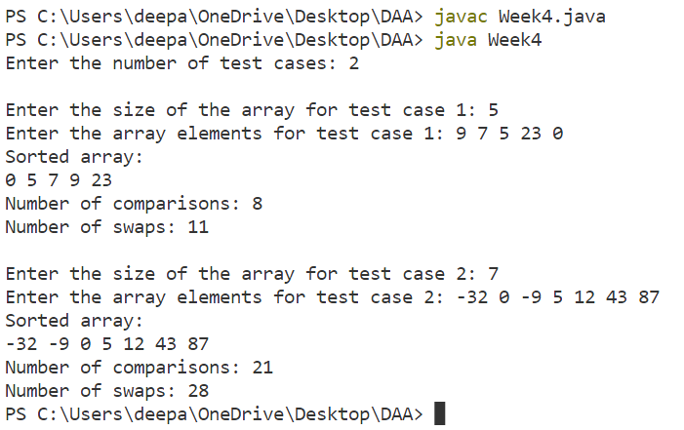

/*   Ques 3. Given an unsorted array of integers, design an algorithm and Implement it using a program to find Kth smallest or largest element in the array. (Worst case Time Complexity = O(n))

*/

import java.util.*;

public class Week4{

    public static int quickselect(int[] arr, int k){

        int left = 0, right = arr.length - 1;

        while(left <= right){

            int pivotIndex = partition(arr, left, right);

            if(pivotIndex == k - 1){

                return arr[pivotIndex];

            }else if(pivotIndex < k - 1){

                left = pivotIndex + 1;

            }else{

                right = pivotIndex - 1;

            }

        }

        return -1;

    }

    public static int partition(int[] arr, int left, int right) {

        int pivot = arr[right];

        int i = left - 1;

        for(int j = left; j <= right - 1; j++){

            if(arr[j] <= pivot){

                i++;

                swap(arr, i, j);

            }

        }

        swap(arr, i + 1, right);

        return i + 1;

    }

    public static void swap(int[] arr, int i, int j){

        int temp = arr[i];

        arr[i] = arr[j];

        arr[j] = temp;

    }

    public static void main(String[] args) {

        Scanner sc = new Scanner(System.in);

        // Input for number of test cases

        System.out.print("Enter the number of test cases: ");

        int T = sc.nextInt();

        // Loop for each test case

        for(int t = 1; t <= T; t++){

            // Input for size of array

            System.out.print("\nEnter the size of the array for test case

" + t + ": ");

            int n = sc.nextInt();

            // Input for array elements

            int[] arr = new int[n];

            System.out.print("Enter the array elements for test case " +

t + ": ");

            for(int i = 0; i < n; i++){

                arr[i] = sc.nextInt();

            }

            System.out.print("Enter the value of K to find Kth smallest

element: ");

            int k = sc.nextInt();

            int kthSmallest = quickselect(arr, k);

            System.out.println(kthSmallest);

        }

    }

}

**\*\*\*\*\*\*\*\*OUTPUT\*\*\*\*\*\*\*\***

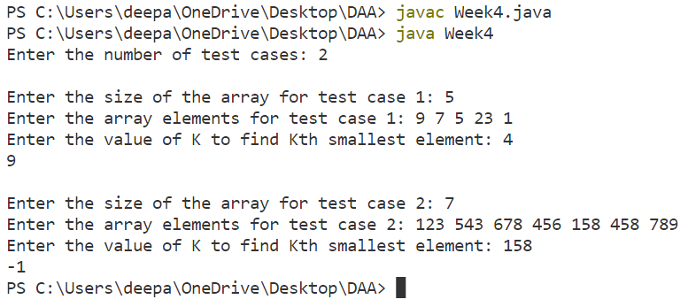

**WEEK – 5:**

/*   Ques 1. Given an unsorted array of alphabets containing duplicate elements. Design an algorithm and implement it using a program to find which alphabet has maximum number of occurrences and print it. (Time Complexity = O(n)) (Hint: Use counting sort)

*/

import java.util.*;

public class Week5{

    public static void main(String[] args) {

        Scanner sc = new Scanner(System.in);

        System.out.println("Enter the number of test cases- ");

        int t = sc.nextInt();

        sc.nextLine();

        while(t-- > 0){

            String s = sc.nextLine();

            int[] count = new int[26];

            for(int i = 0; i < s.length(); i++){

                char c = s.charAt(i);

                count[c - 'a']++;

            }

            int maxCount = 0;

            int maxCountIndex = 0;

            for(int i = 0; i < 26; i++){

                if(count[i] > maxCount){

                    maxCount = count[i];

                    maxCountIndex = i;

                }

            }

            char maxOccurringAlphabet = (char) (maxCountIndex + 'a');

            System.out.println("Max occurring alphabet: " +

maxOccurringAlphabet + " " + maxCount);

        }

    }

}

**\*\*\*\*\*\*\*\*OUTPUT\*\*\*\*\*\*\*\***

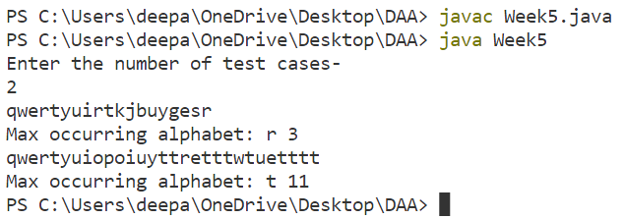

/*   Ques 2. Given an unsorted array of integers, design an algorithm and implement it using a program to find whether two elements exist such that their sum is equal to the given key element. (Time Complexity = O(n log n))

*/

import java.util.*;

public class Week5{

    public static void main(String[] args) {

        Scanner sc = new Scanner(System.in);

        // Input for number of test cases

        System.out.print("Enter the number of test cases: ");

        int T = sc.nextInt();

        // Loop for each test case

        for(int t = 1; t <= T; t++){

            // Input for size of array

            System.out.print("\nEnter the size of the array for test case

" + t + ": ");

            int n = sc.nextInt();

            // Input for array elements

            int[] arr = new int[n];

            System.out.print("Enter the array elements for test case " +

t + ": ");

            for(int i = 0; i < n; i++){

                arr[i] = sc.nextInt();

            }System.out.print("Enter the key element: ");

            int key = sc.nextInt();

            Arrays.sort(arr);

            int left = 0, right = n - 1;

            while(left < right){

                int sum = arr[left] + arr[right];

                if(sum == key){

                    System.out.println(arr[left] + " " + arr[right]);

                    return;

                }else if(sum < key){

                    left++;

                }else{

                    right--;

                }

            }

            System.out.println("No elements found");

        }

    }

}

**\*\*\*\*\*\*\*\*OUTPUT\*\*\*\*\*\*\*\***

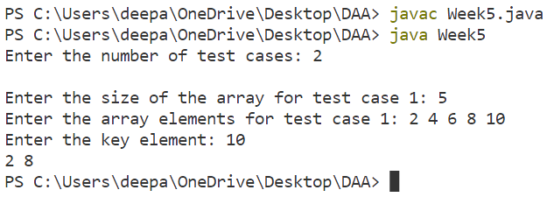

/*   Ques 3. You have been given two sorted integer arrays of size m and n. Design an algorithm and implement it using a program to find list of elements which are common to both. (Time Complexity = O(m+n))

*/

import java.util.*;

public class Week5{

    public static void main(String[] args) {

        Scanner sc = new Scanner(System.in);

        System.out.print("\nEnter the number of tese cases: ");

        int T = sc.nextInt();

        for(int t=1;t<=T;t++){

            System.out.print("Enter the size of test case " + t + " array 1: ");

            int m = sc.nextInt();

            int[] arr1 = new int[m];

            System.out.print("Enter the elements of array 1: ");

            for (int i = 0; i < m; i++) {

                arr1[i] = sc.nextInt();

            }

            Arrays.sort(arr1);

            System.out.print("Enter the test case " + t + " size of array 2: ");

            int n = sc.nextInt();

            int[] arr2 = new int[n];

            System.out.print("Enter the elements of array 2: ");

            for (int i = 0; i < n; i++) {

                arr2[i] = sc.nextInt();

            }

            Arrays.sort(arr2);

            int i = 0, j = 0;

            System.out.print("Common elements: ");

            while (i < m && j < n) {

                if (arr1[i] == arr2[j]) {

                    System.out.print(arr1[i] + " ");

                    i++;

                    j++;

                } else if (arr1[i] < arr2[j]) {

                    i++;

                } else {

                    j++;

                }

            }

        }

    }

}

**\*\*\*\*\*\*\*\*OUTPUT\*\*\*\*\*\*\*\***

